Competitive Shooters of Lake Norman USPSA November 13th, 2025
COURSE DESIGNER: Rocky Perillo
START POSITION: See written stage briefings.

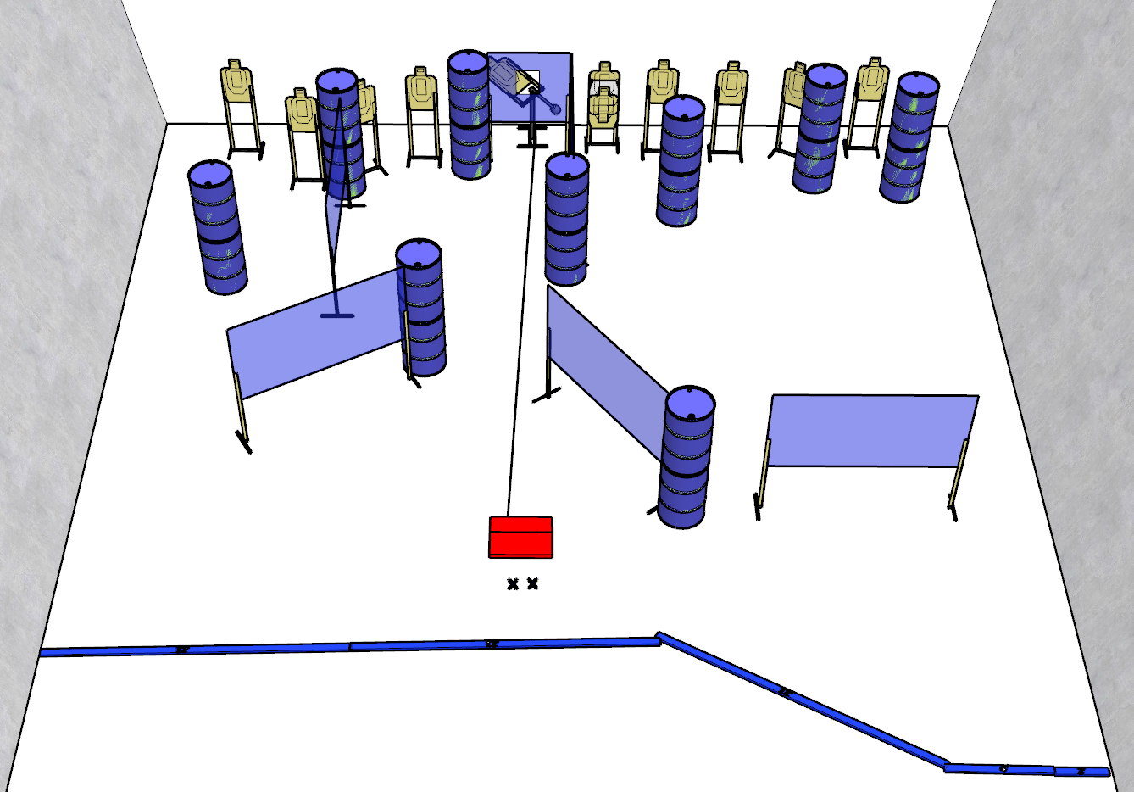

Written Stage Briefing:

Stage 3 - Your Name Is Buck...Right? - is a 24-round, 120 point, Comstock Course. There are 11 cardboard targets and some noshoots. The best 2 hits per static cardboard target will be scored. The best 4 hits on the mover will be scored.
Handgun start position Feet on Xs. The handgun is loaded and holstered.
PCC start position Feet on Xs. PCC is loaded with stock touching belt.
On the audible start signal, engage targets from within the shooting area.

